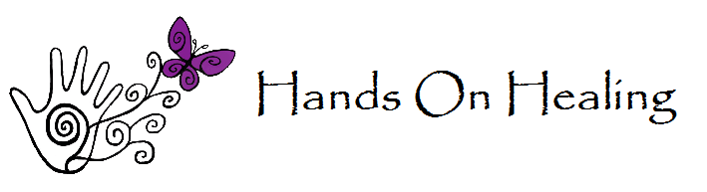
Cupping Consent Form
I have been informed that bruising is a common side effect of cupping. Contraindicates include rashes, allergic dermatitis, other skin lesions, high fever, severe disorders/diseases such as cardiac failure, edema, hemophilia, and leukemia. It cannot be performed on the abdomen or lower back of pregnant women. Unusual/rare risks include burns when used with fire cupping or blisters during intensive sessions. Cupping is great for poor circulation, muscle tension, loosening adhesions, respiratory disorders, digestion disorders, as well as other things like general anxiety. Cupping uses suction to pull up on areas of the skin and can put left in place for approximately 10 minutes or with the use of oil moved across the skin. Your practitioner will discuss with you what kind would benefit you.

Client Name (Print): ________________________________________
Client Name (Signature): ____________________________________
Date: ___________________________________________________

